SC

Oruka announced interim Ph1 data for ORKA-002 in healthy volunteers, supporting Phase 2 initiation in PsO & HS

Company: Oruka Therapeutics  Drug: ORKA-002 (SC, IL17A/F) | Date: January 12th, 2026  Source(s): Press Release, Presentation
What happened:
- Oruka Therapeutics announced positive interim data from the Phase 1 trial of ORKA-002 in healthy volunteers demonstrating a half-life of 75-80 days
- PK profile supports potential twice-yearly (Q6M) dosing in PsO and quarterly (Q3M) dosing in HS
- Oruka plans to initiate the Phase 2 ORCA-SURGE trial in moderate-to-severe PsO in 1H 2026 (Primary Endpoint: PASI 100 at week 16) with a topline data expected in 2027, followed by a Phase 2 trial in HS in 2H 2026

Impact (CI PoV): MEDIUM
- Oruka is proposing a two-maintenance dose per year paradigm for PsO which Oruka believes could differentiate ORKA-002 vs. Bimzelx’s Q8W maintenance dosing. Additionally, Oruka is positioning ORKA-002 as the first potential quarterly biologic for HS challenging Bimzelx’s Q4W maintenance in HS
- CI projects potential earliest US/EU approval for ORKA-002 in PsO in Q2 2031, assuming Phase 3 initiation by Q1 2028 and submission by Q2 2030 and Q3 2031 in HS using H2 2026 Phase 2 trial initiation guidance

Why it matters (CI Insights in blue italics):
- ORKA-002 targets the same dual cytokine epitopes (IL-17A/F) as Bimzelx but offers a significantly reduced injection burden with less frequent dosing
  - This represents the first clinical validation of ORKA-002’s extended half-life previously observed in Oruka’s NHP data presented at AAD 2025
- Oruka’s messaging relies on the "freedom from disease" narrative, aiming to commoditize existing biologics by offering highest possible rates of disease clearance in the fewest number of doses

Tell me more:
- In 24 healthy volunteers, ORKA-002 showed a half-life of 75-80 days (>3x that of Bimzelx)
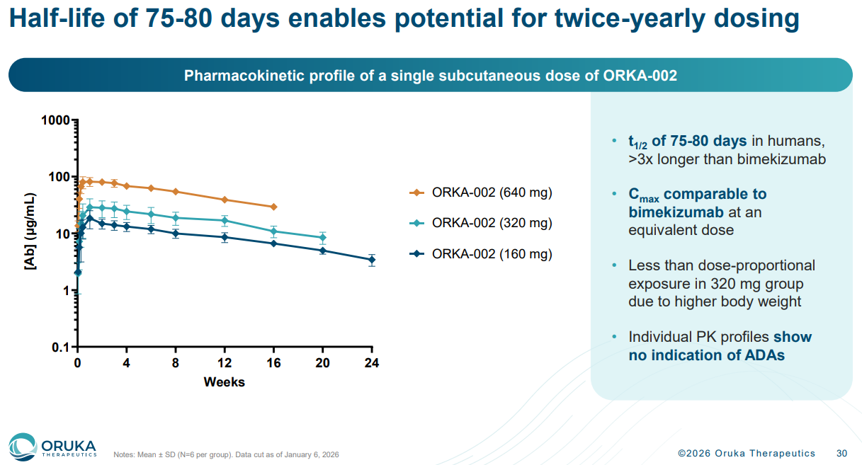
  - Pharmacokinetic modeling based on these results supports achieving twice-yearly maintenance dosing in PsO and quarterly maintenance dosing in HS
  - A comparable Cmax to bimekizumab at equivalent doses based on previously reported bimekizumab data
    - We interpret this statement to suggest that ORKA-002 drug exposure may not differentiate from bimekizumab in PsO and HS
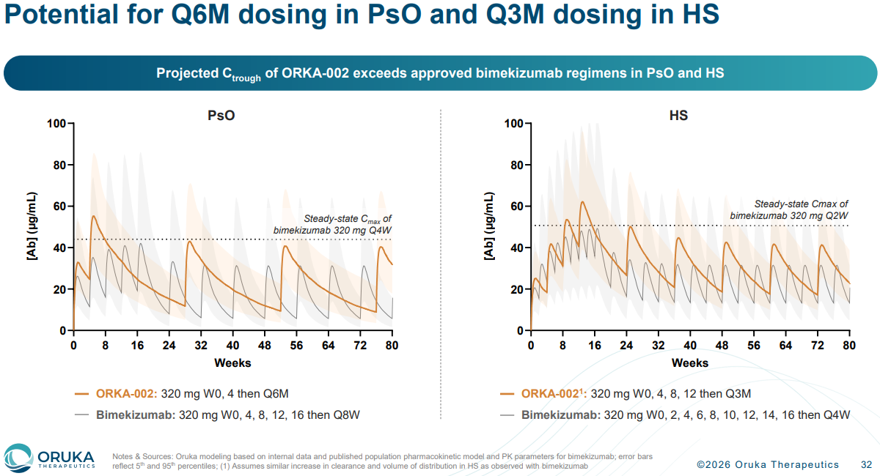

- Favorable safety profile with no severe TEAEs:
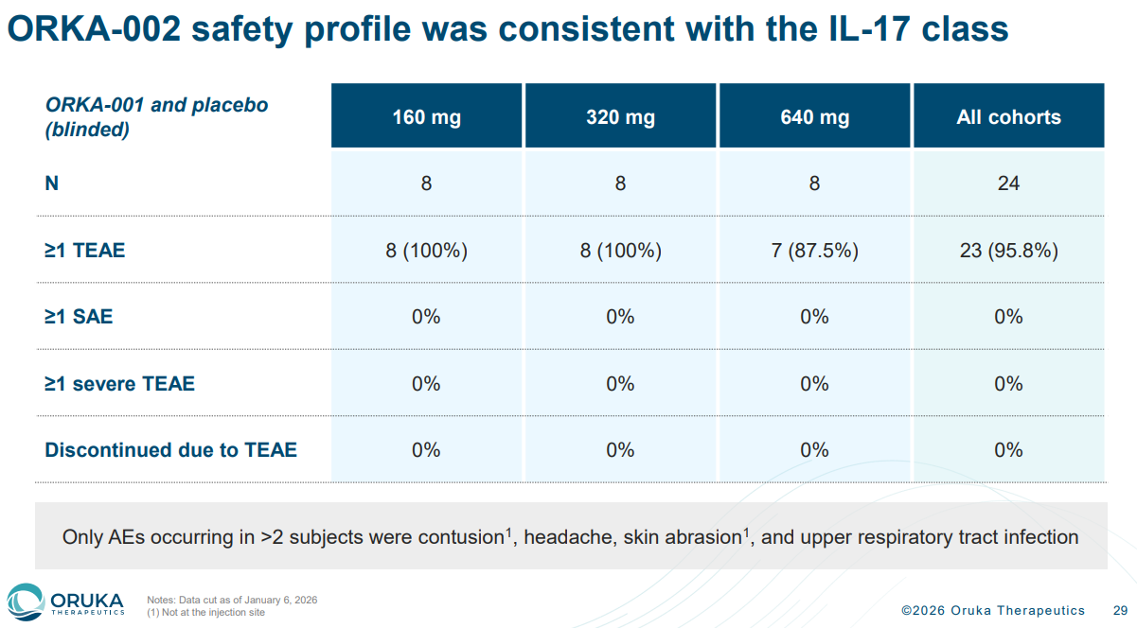
- The Phase 2 ORCA-SURGE trial in PsO will evaluate ORKA-002 at 40mg, 160mg and 320mg vs placebo
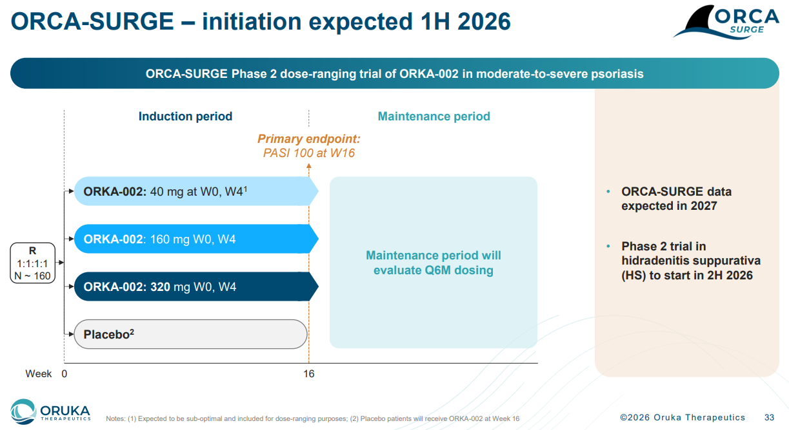
- Recall, in December Oruka registered EVERLAST-B, a Phase 2b dose range finding study evaluating ORKA-001 (IL-23p19) in adults with moderate-to-severe PsO with interim data now expected in 2H 2026 and topline data in 2027
  - CI projects potential earliest US/EU approval for ORKA-001 in PsO in late 2030, assuming Phase 3 initiation by year end 2027 and expedited timelines
- Oruka’s strong cash position as of the Q3 Earnings of >$500M cash, supported by the September $180M PIPE financing, provides runway >1 year beyond three major readouts
  - EVERLAST-A Phase 2a in 2H 2026, EVERLAST-B Phase 2b in 2027, and ORCA-SURGE Phase 2 in 2027
- Oruka highlighted pipeline-in-a-product expansion potential for ORKA-002 including PsA, HS, axSpA, and others
  - Oruka’s pipeline also includes ORKA-021 which is a sequential combination of ORKA -002 and ORKA -001; positioned by the company for “rapid response with ideal maintenance profile”

For questions, please reach out to:
 | Dermatology | Rheumatology | Gastroenterology
APEX (US/PCS) | Chanda Bhat | Bethany Christmann | Luke Versten
IMABI (International/ Affiliates) | Priti Anand | Irene Knorn | Priti Anand

Invite your colleagues to inVision | Manage Email Preferences | Unsubscribe

This document/email contains competitive intelligence collected via an approved competitive intelligence supplier working on behalf of AbbVie. We collect competitive intelligence consistent with industry standards and AbbVie policy. Not for field distribution. Please reach out to APEX/IMABI, Legal, or OEC teams with any questions.

